**INTI International College Penang School of Engineering and Technology**

**3+0 Bachelor of Science (Hons) in Computer Science, in collaboration with Coventry University, UK**

**3+0 Bachelor of Science (Hons) in Computing, in collaboration with Coventry University, UK**

**Coursework cover sheet**

**Section A - To be completed by the student**

|  |  |
| --- | --- |
| Full Name: CHU ZHI XUAN | |
| CU Student ID Number:12673128 | |
| Semester: JAN 2022 | |
| Session:  **April 2022** | |
| Lecturer:  **Nadhrah Abdul Hadi (nadhrah.abdulhadi@newinti.edu.my)** | |
| Module Code and Title:  **4067CEM Software Design** | |
| Assignment No. / Title:  **Continuous Assessment** | % of Module Mark:  **50** |
| Hand out Date:  **22nd April 2022** | Due Date:  **Task 1: 13 May 2022, by 11.59pm**  **Task 2: 1 July 2022, by 11.59pm**  **Task 3: 17 June 2022, by 11.59pm.**  **Task 4: 17 June 2022, by 11.59pm.**  **Task 5: 17 June 2022, by 11.59pm.** |
| Penalties: No late work will be accepted. If you are unable to submit coursework on time due to extenuating circumstances, you may be eligible for an extension. Please consult the lecturer. | |
| Declaration: I/we the undersigned confirm that I/we have read and agree to abide by the University regulations on plagiarism and cheating and Faculty coursework policies and procedures. I/we confirm that this piece of work is my/our own. I/we consent to appropriate storage of our work for plagiarism checking.  Signature(s): ________________________ | |

**Section B - To be completed by the module leader**

|  |  |  |
| --- | --- | --- |
| Intended learning outcomes assessed by this work:  1. Understand and apply appropriate concepts, tools and techniques to each stage of the software development  2. Understand and apply design patterns to software components in developing new software  3. Demonstrate an understanding of project planning and working to agreed deadlines, along with professional, interpersonal skills and effective communication required for software production  5. Demonstrate an awareness of, and ability to apply, social, professional, legal and ethical standards as documented in relevant laws and professional codes of conduct such as that of the Malaysian National Computer Confederation. | | |
| Marking scheme | Max | Mark |
| 1. User Story Mapping 2. Setting up a GitHub Repository 3. Creating a Class diagram and design pattern selection 4. Creating a Prototype User Interface and Usability Testing 5. Discuss the ethical issue related to the software | 20  10  30  20  20 |  |
| Total | 100 |  |

**Task 1**

Vision

The goals for design the college event management are create a suitable platform which are automation capabilities save time and cost. In this system, we have two user which are student and organiser.

User of system

* Student and club college

Value and benefits

From this system, the organiser can value their event by tracking the attendance of event by implement the analysis technique. The students also can browse the event and do the online registration in online. The organiser can direct promote the event to the student by sending the notification by email.

Backlog with goals

* Design the event management system for college
* Able student to view and enrol the event
* Able the student join the club through online and can view the club details
* Able the club to take attendance of student during event
* Able the club to post their event and send the notification to the member

The user stories are done by the google forms survey by sending the link to my friends.

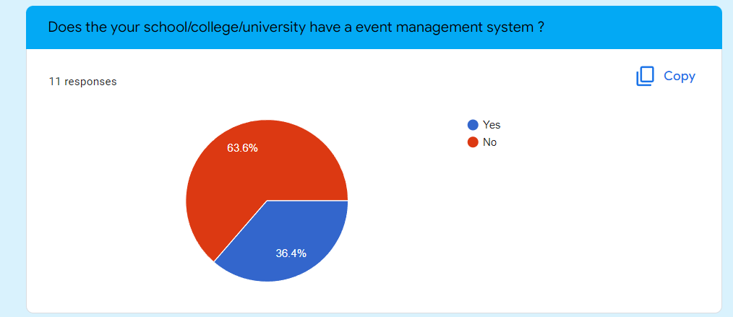

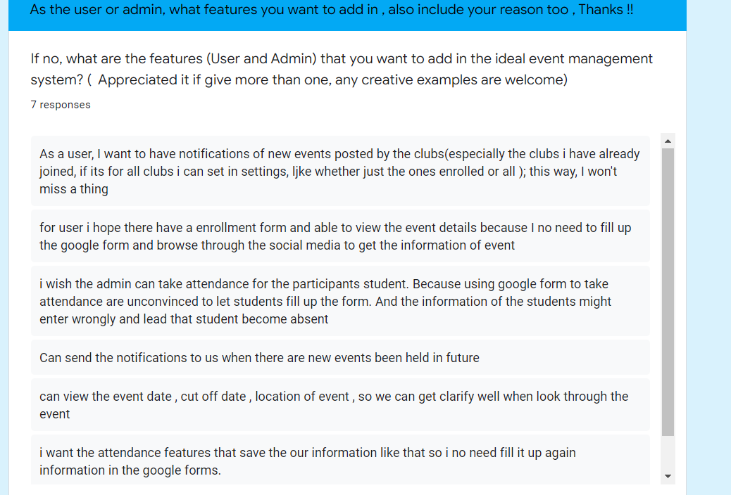

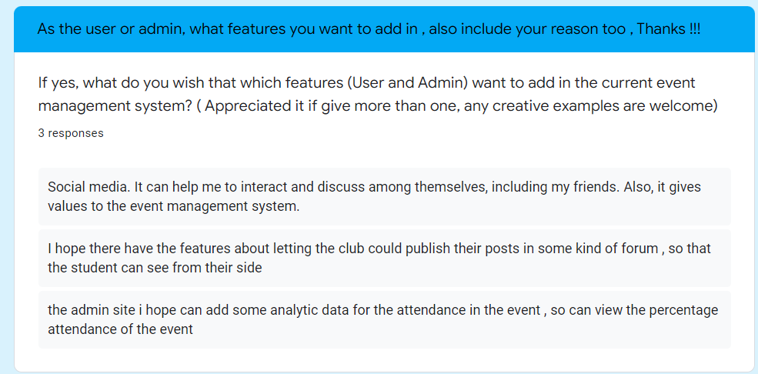

User Mapping Story

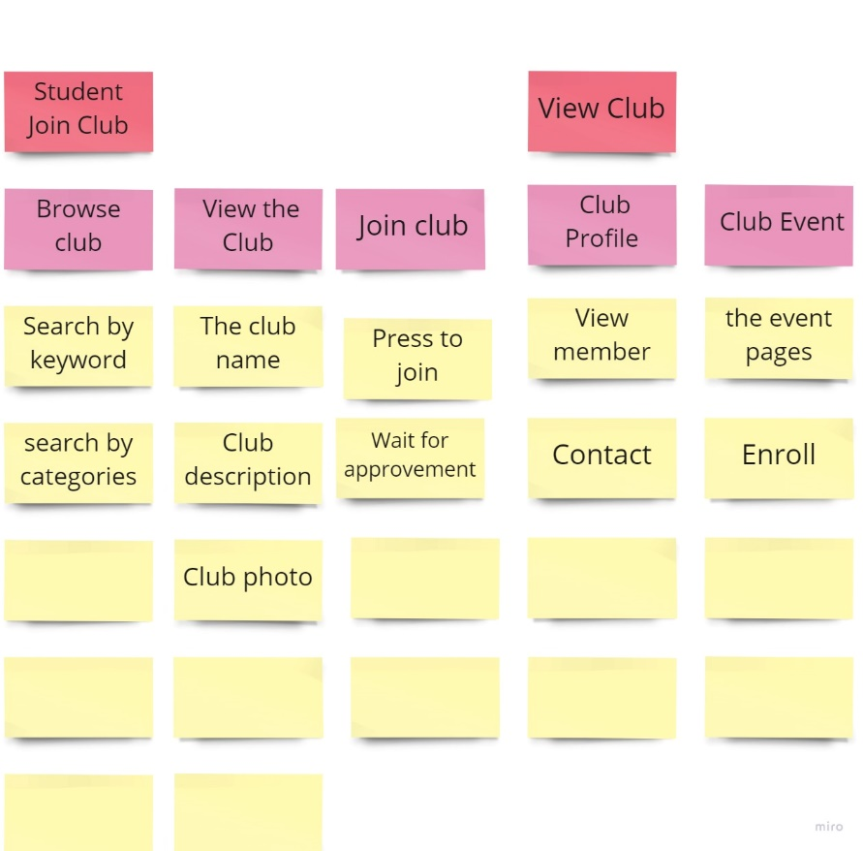

Goals

Activities

Task

Activities

Goals

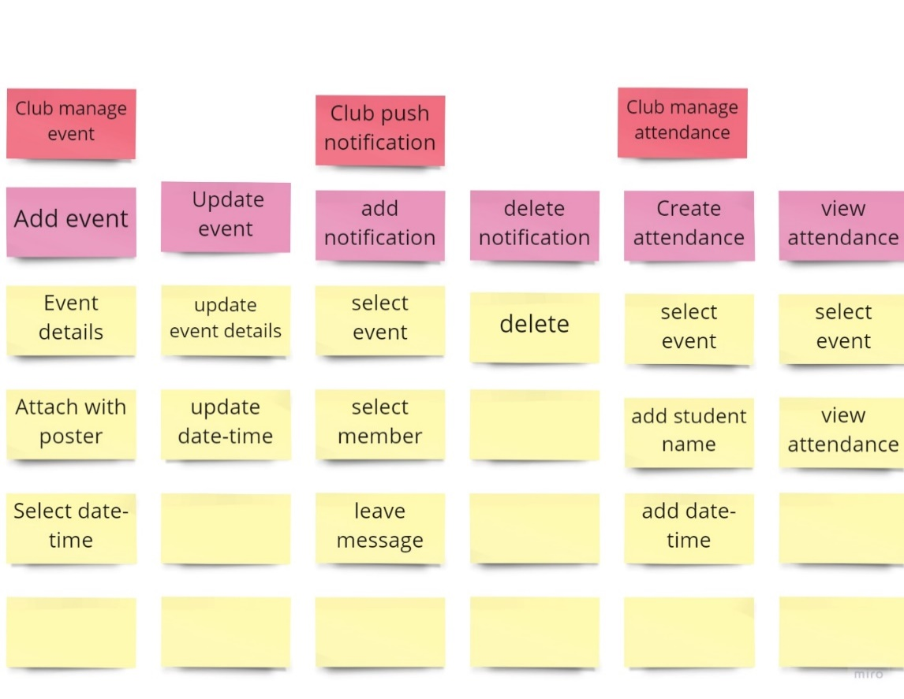

Task

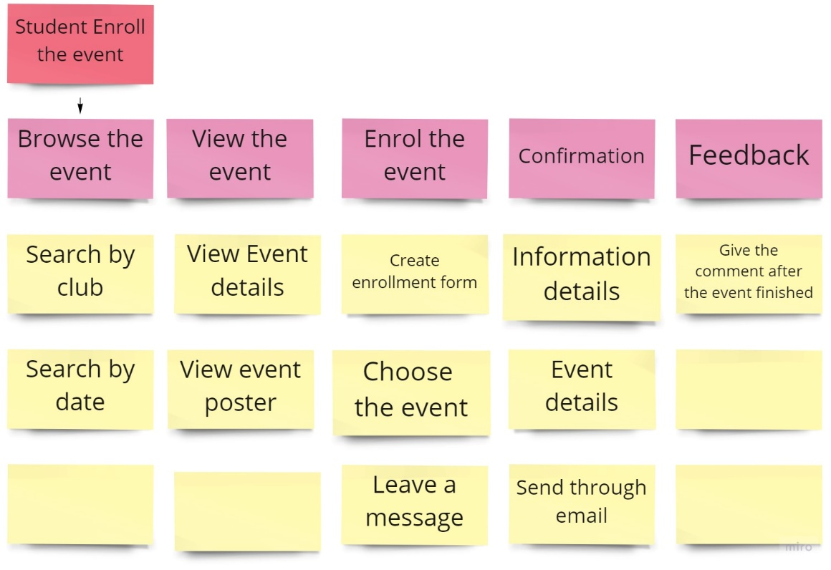

Goals

Task

Activities

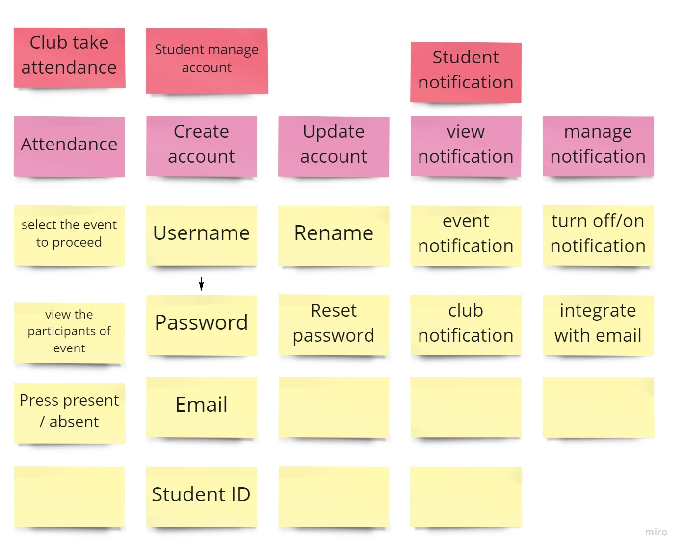

Goals

Activities

Task